YOU ARE INVITED TO A MEETING OF WHITCHURCH VILLAGE COUNCIL
WHICH IS TO BE HELD
IN THE WVCA HALL ON WEDNESDAY 7th JANUARY 2026 AT 7.30.p.m.

THE PUBLIC ARE INVITED TO ATTEND
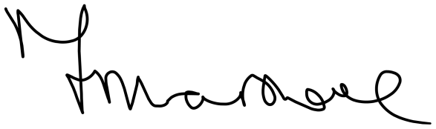
F Marshall - Clerk – 24 December 2025

AGENDA

- Public Participation
This provides an opportunity for members of the public to raise questions about and comment upon matters within the jurisdiction of the Council.
The maximum time for this session is 30mins, 3mins per individual.
If you wish to speak, please notify the Clerk in writing/by e-mail, no later than 24hrs before the meeting, with your name, address, and subject matter.
- Apologies for absence - to commence no later than 8.00.p.m.
- To receive any Declarations of Interests under Whitchurch Village Council’s Code of Conduct
(adopted on 7th November 2012)
- To receive, consider and grant any dispensations (for disclosable pecuniary interests)
- To confirm the minutes of the Ordinary Village Council Meeting held on 3rd December 2025
- To confirm meeting dates for Playfield/Cemetery/Allotments and Finance Committees
- Christmas Lights Switch On
a) To debrief on Christmas lights, switch on from December 2025 and agree improvements for 2026
b) To discuss date for 2026 Christmas Event
c) To agree with continuing the competition for Christmas card design from the school.
- Planning and Traffic:
- To note the current Planning Application list
- Clerks Report
- Items of Interest from District Councillor Paul May B&NES
- Field, Cemetery & Community Gardens (Allotments)
a) To Grant Exclusive Rights of Burial
12. Finance
a) To note and agree the payment of accounts dated 7th January 2026
b) To receive an update on Cil funds and agree any actions.
13. To receive an update and consider a request form the Chair of the WVCA to use the Village Council Wifi

The date of the next meeting is Wednesday 4th February 2026

All Correspondence to the Clerk by: Tuesday 27th January 2026.

Whitchurch Village Council,

Community Centre Office, Bristol Road, Whitchurch, Bristol, BS14 0PT

E-mail: info@whitchurchvillagecouncil.co.uk Tel: 01275 839873

